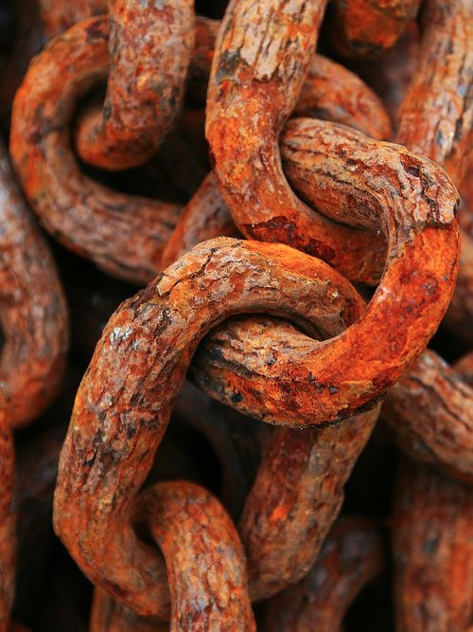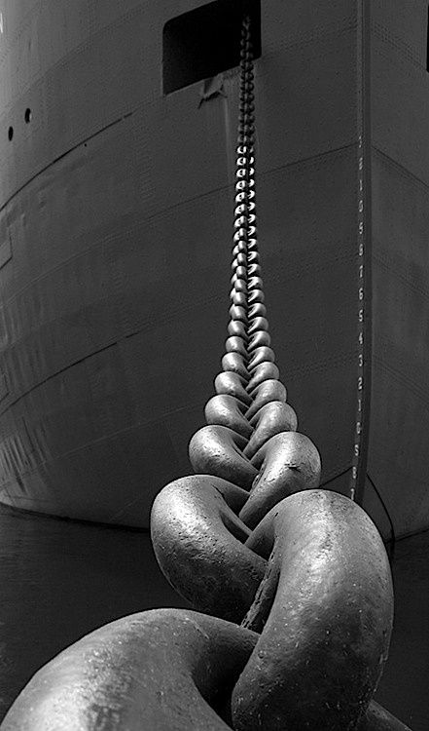

The Chain Across the Medway: 350th Anniversary of the Battle of Medway

To commemorate the anniversary of the Battle of Medway, staff and students of the Jewellery & Silversmithing Department at the University for the Creative Arts in Rochester would like to re imagine one of the iconic symbols of the battle, the Chain Across the Medway. This 300 yard long chain also known as a boom was an obstacle strung across a navigable stretch of water to control or block navigation. Our chain was used during the Second Anglo-Dutch War in June 1667, to repel the Dutch navy.

A newcomer to Kent having relocated from Edinburgh, Scotland 3 years ago, the chain across the Medway was one of the first stories that I heard about as I explored the local area, and one that immediately captured my imagination. As a metal worker used to dealing with fine chain made in precious metals the sheer scale of the endeavor of the Medway Chain was impossible to ignore.

We would like to propose a project that captures the enormity and ambition of the original chain but to reconsider the chain not as a barrier but as a celebration of hand skills, community, collaboration and connection. Our project would see the recreation of the chain to the full 300 yards as a single length but with one difference, our chain would be constructed from multiple handmade chains designed and hand crafted by each of our staff and students. Each one of these individually made chains would be connected together to form the whole 300 yards. Our project does not end in Rochester; we would like to use the chain as a means of connection establishing links to a similar university or college in the Netherlands, asking them to collaborate with us and contribute their sections of chain.

We feel that the project also has the potential to include local schools, asking them to participate in workshops and contribute towards the new Medway Chain. The project could also be designed to tap into the wealth of knowledge that exists in the area from retired former shipyard workers in knowledge sharing workshops.

We see the project as promoting:

- Hand skills: The chain will be constructed from individually hand made sections of chain by both BA and MA students currently studying at UCA Rochester.

- Community: We would like to expand the project running short workshops with local schools to get them to make chain for the event. This would build a tangible connection to local history and establish new links within the local area.

- Collaboration: We want to use the chain as a means of collaborating with students from Kent and the Netherlands; sharing sills and knowledge.

- Connection: The original chain was used as a barrier however the new chain will be seen as a symbol of connection bringing together communities from the UK and abroad.

Grant McCaig MA RCA, FHEA
Senior Lecturer Silversmithing, Goldsmithing & Jewellery
gmccaig@ucreative.ac.uk
01634888652

